

**ASSIGNMENT BRIEF – BTEC**

|  |  |  |  |  |  |  |
| --- | --- | --- | --- | --- | --- | --- |
| **Course/Qualification** | | | BTEC Level 3 Extended Diploma in Creative Media Production | | | |
| **Unit Number(s) and Title covered** | | | Unit 15: Developing a Small Business | | | |
| **Assignment Title and Number** | | | Assignment 1: Skills and Resources | | | |
| **Student Name** | | | Lewis Hawkins | | | |
| **Assessor** | | Bradley Chinn | | **Internal Verifier** | David Matravers | |
| **Date issued** | | 03.10.2018 | | **Submission deadline** | 18.10.2018 at 16:30 | |
| **Assessment Criteria** | **To achieve the criteria, the evidence must show that the student is able to:** | | | | | **Assessor confirm met** |
| **P1** | Describe the skills and resources required to develop a small business in the creative media sector with some appropriate use of subject terminology. | | | | | Y |
| **M1** | Explain the skills and resources required to develop a small business in  the creative media sector with reference to detailed illustrative examples and with generally correct use of subject terminology. | | | | | N |
| **D1** | Comprehensively explain the skills and resources required to develop a small business in the creative media sector with elucidated examples and consistently using subject terminology correctly. | | | | | N |

|  |  |  |  |  |  |  |  |
| --- | --- | --- | --- | --- | --- | --- | --- |
| **Assessor feedback - 1st submission** | | | | | | | |
| Well done Lewis, you have managed to achieve the pass criteria for this assessment.  You have described the skills and resources required to develop a small business in the creative media sector with some appropriate use of subject terminology.  However, work doesn’t have clear examples with explanations and this will prevent you from achieving the higher grades.  Overall, you have achieved the pass criteria and have an opportunity to rework for the higher grades (Subject to the Lead IV’s Decision). | | | | | | | |
| **Did the learner meet the original deadline or agreed extension?** | | Yes | | | | | |
| **Assessor signature** |  | | | | **Date** | | 02/11/2018 |
| **Resubmission authorised?** | | Yes | | | | | |
| **New agreed deadline date for submission** *\* must be within 15 days of receiving original assignment back* | | **28/11/2018** | | | | | |
| **Lead Internal Verifier signature** | H:\My Pictures\Jim Signature.jpg | | | **Date** | | **12/11/2018** | |
| **Assessor feedback - Resubmission** | | | | | | | |
|  | | | | | | | |
| **Assessor signature** (resubmission only) |  | | **Date** | | | |  |

|  |
| --- |
| **Vocational Scenario/Industrial Context** |
| GameVision, a small start-up business, currently employs 4 members staff in the provision and is looking to recruit a member to its business development team.  Games vision are in need of a clear report of the type of skills and resources which they will need to start initiating the start-up of their business. You must write some information that will help support your new business owner and identify clear skills and resources they will need to complete daily tasks. |
| **Tasks and criteria covered** |
| **Task 1 – P1, M1, D1**  For this task you are required to comprehensively explain why the following skills and resources are important for a small business in the creative industry; using examples to fully support your points:  Below in **bold** you will see the range of skills and resources that you have to explain along with *italicised* headings (that you **should consider discussing**).   * **Skills:** *creative; sales; marketing; management; financial; technical; operational (recording and checking performance of business, administration, planning, scheduling); strengths and weaknesses; previous experience; self-presentation; corporate presentation* * **Resources***: location and facilities (cost, accessibility, communications, hardware, software, floor space requirements, scope for expansion or contraction, potential for outsourcing of key operations); suppliers; service providers; asset requirements; professional support; training*   This will need to be formatted in report style as this will be a professional document for the owner to read. |
| **Evidence you must produce for this task** |
| A written word document evidencing task 1. |
| **Sources of information** |

|  |  |  |  |
| --- | --- | --- | --- |
| **Textbooks**  Baylis P, Freedman A, Procter N et al – BTEC Level 3 National Creative Media Production, Student Book  (Pearson, 2010) ISBN 978-1846906725  Baylis P, Freedman A, Procter N et al – BTEC Level 3 National Creative Media Production, Teaching Resource  Pack (Pearson, 2010) ISBN 978-1846907371  Deakins D – Entrepreneurship and Small Firms (McGraw-Hill, 1996) ISBN 978-0077121624  Golzen G – Working for Yourself, 18th Edition (Kogan Page, 1998)  Oates D – The Small Business Bible (Arrow, 1995) ISBN 978-0099439219  Stokes D R – Small Business Management (Thompson Learning, 2002) ISBN 978-0826456793  Vass J – The ‘Which?’ Guide to Starting Your Own Business (Which Books, 1999) ISBN 978-0852029305  Wisdom J – Checklists and Operating Forms for Small Businesses (John Wiley & Sons, 1997)  ISBN 978-0471115625  **Websites**  www.abi.org.uk – the Association of British Insurers  www.bbc.co.uk – BBC website which provides access to related resources via its webwise sub-directory  www.britishchambers.org.uk – business support, offering a ready-made management support team for any  business, anywhere in the UK  www.businesslink.gov.uk – a website managed by the Department of Trade and Industry, offering practical  advice for small businesses, including advice on starting up  www.bvca.co.uk – represents the vast majority of venture capital and private equity in the UK and is  dedicated to promoting the industry for the benefit of entrepreneurs, investors, its practitioners and the  economy as a whole  www.cim.co.uk – the Chartered Institute of Marketing  www.companies-housegov.uk – Companies House  www.dti.gov.uk – the Department of Trade and Industry  www.enterprisezone.org.uk – the Enterprise Zone  www.e-technologies.co.uk – provides a number of interactive business support tools  www.ft.com – provides topical editorial from The Financial Times  www.gamasutra.com – a comprehensive website on the games development industry run by Game  Developer magazine and Gamasutra, covering industry news, jobs, and education  www.hsegov.uk – the Health and Safety Executive  www.inlandrevenuegov.uk/home.htm – the Inland Revenue  www.lloydstsbbusiness.co.uk – Lloyds TSB Small Business Guide  www.sfedi.org.uk – the Small Firms Enterprise Development Initiative  www.skillset.org – Skillset, the Sector Skills Council for the creative media sector | | | |
| **Student checklist** | | | **Complete?** |
| Proofread | | |  |
| Reference List (if applicable) | | |  |
| All pages attached and numbered – including introduction/conclusion/front sheet | | |  |
| **Authenticity of Evidence Student declaration** | | | |
| I certify that the evidence submitted for this assignment is my own.  I have clearly referenced any sources used in the work.  I understand that false declaration of authenticity (i.e. plagiarised work) is a form of academic misconduct and the relevant College procedures will be instigated if I am found to be in contravention of these. | | | |
| **Student signature** |  | **Date of submission** | 18/10/18 |
| **Re-authentication of Evidence Student declaration *(for resubmission only)*** | | | |
| **Student signature** |  | **Date of resubmission** | 28/11/18 |

**Task 1**

* **Skills:** *creative; sales; marketing; management; financial; technical; operational (recording and checking performance of business, administration, planning, scheduling); strengths and weaknesses; previous experience; self-presentation; corporate presentation*
* **Resources***: location and facilities (cost, accessibility, communications, hardware, software, floor space requirements, scope for expansion or contraction, potential for outsourcing of key operations); suppliers; service providers; asset requirements; professional support; training*

**Skills:**

**Departments:** The departments are groups of individuals who are responsible for the creation and maintenance of the areas they work in. The departments are listed below.

**Creative:** Thisis the department which is responsible for all the creative areas in game development. These areas include 3D modelling, Concepting, Story Design, Animation, and Gameplay Design. This department is the key for making the game enjoyable.

The concept artists give concept art to the 3D modelers, they then make the models and pass them onto the Textures who UV unwraps the models and texture them. The story and gameplay designers work with the concept artists to create assets together which are modelled and passed on to the animators who animate and rig the models. They’re then implemented into the game by programmers and others that work on the engine.

**Concept Artists,** create images and 3D models of items, characters, or levels which are created by combining many ideas, from unique and existing creations. Below is an image of concept art I made in 3D.



**Story Designers,** are tasked with creating an immersive and interesting story for the players to be involved in. The story can take years to finalise and requires many proof reads and changes until its completed. This is in most cases the longest part of the game’s development.

Below is an image of a story I’ve concepted.

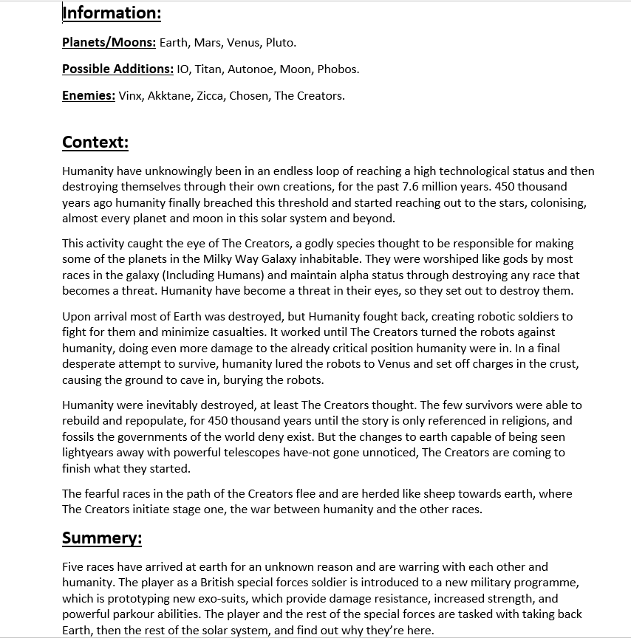

**Game Play Designers,** concept and test game features which are sometimes small like an easter egg, or large such as a new class of playable characters. These desitions determin how the game plays and feels to the player and is very important from the beginning to post launch DLCs.



**3D Modelers,** make the models for the game. They create almost all the 3D assets in games by working with the other sub departments in creative to bring the games visuals together. Below is a model I made.



**Textures,** Take the model and UV unwrap it. They then take the UV map into a image eniting software like Photoshop or Gimp. In the software the textures draw on the map to create the textures. However this is not the ideal method for complex and high res textures. For photorealistic textures the best and quickest option is to use softwere like Substance Painter, which allows the developer to paint directly onto the model. Theres also filters and modifires to easily create prosidual scratches, dirt, etc.

Below is an image of my texturing work.



**Animators,** make the models come to life by creating animations. It could be just a simple walk cycle or it could be a complex cutscene

**Programmers:**

**Sales:** In this department the resources are dedicated to working with customers to make sure they get their product, mass selling copies of the game to retail outlets, and identifying trends in the industry.

**Marketing:** This department is responsible for pushing the game into the public eye. They design posters and other promotional material such as TV advertisements. Without this department the game studio’s product would have to rely on luck to succeed.

**Management:** This is the team that oversees planning, organizing, staffing, leading/directing, controlling/monitoring, and motivating. They act as the bridge between departments, making all the tough decisions that fit into the categories above.

**Financial:** The financial department oversee everything financial which includes accounting, financial statements, planning (Financial side), and organising (Financial side).

**Resources:**

**Location and Facilities:** The location of your business can be very crucial to a business’s survival (Depending on the business’s needs). For example, in a city (London) you’re more likely to find a building that suits your needs, however it will be more expensive. But, the ability to expand is important even if you think you might not want to. So, it’s best to pick a location where you can expand if needed.

Hardware and software are also a requirement as without them the business would be unable to work.

Hardware: Computer (GPU, CPU, etc), monitors, keyboards, mice.

Software: Blender, 3Ds max, Maya, Photoshop, Gimp, Substance Painter.

**Suppliers:** A supplier is a party that offers goods or services. They’re distinguished from contractors who commonly add specialized input to deliverables.

**Service Providers:** Service Providers are suppliers of internet, software subscriptions, and building rent. The service providers are both an advantage and disadvantage at the same time. While they do require annual payments of sometimes thousands, the do offer services and compensation if the software fails to meet expectations.

**Training:** Training is key to passing on information through staff. This is arguably the most influential part of the integration process. This is an additional layer to the information you’d learn in a course and is used to give the employee first-hand experience in the job they’ve got.